**Ideation Phase**

**Define the Problem Statements**

**Customer Problem Statement Template:**

Create a problem statement to understand your customer's point of view. The Customer Problem Statement template helps you focus on what matters to create experiences people will love.

A well-articulated customer problem statement allows you and your team to find the ideal solution for the challenges your customers face. Throughout the process, you’ll also be able to empathize with your customers, which helps you better understand how they perceive your product or service.

**Example:**

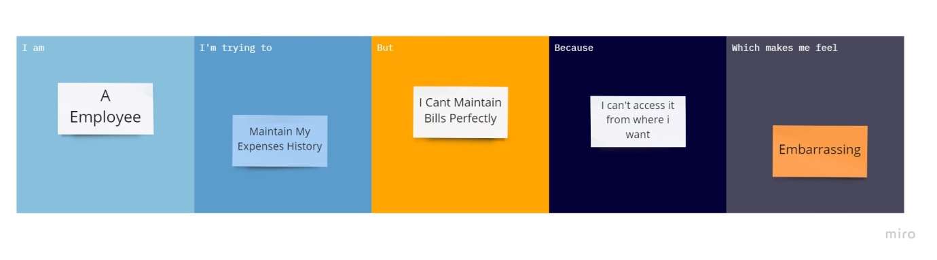

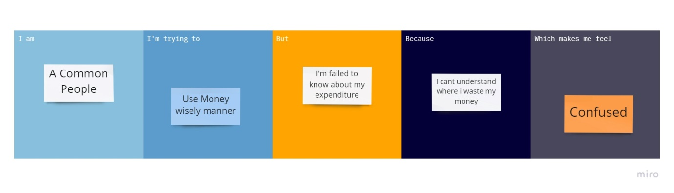

|  |  |  |  |  |  |
| --- | --- | --- | --- | --- | --- |
| **Problem Statement (PS)** | **I am (Customer)** | **I’m trying to** | **But** | **Because** | **Which makes me feel** |
| PS-1 | A Employee | Maintain my expense History | I can’t maintain bill properply | I can’t access it from where I want | Embarrassing |
| PS-2 | A Common People | Use Money wisely manner | I'm failed to know about my expenditure | I cant understand where i waste my money | Confused |